# National Education Day

# Why do we celebeate national education day

National Education Day is celebrated on November 11 every year in honor of **Maulana Abul Kalam Azad,** the first Education Minister of independent India and a prominent educationist. This day highlights the importance of education in shaping India's future. With 65% of the nation's population under the age of 35, it is crucial to provide them with opportunities for quality education and skills development. The Government of India is dedicated to building strong education infrastructure that fosters the holistic development of students and empowers the youth to drive the nation towards progress.

# The Government of India has taken significant strides to promote access to education through various initiatives and constitutional provisions. The introduction of free primary education, reinforced by the **86th Amendment of the Constitution through Article 21-A**, guarantees free and compulsory education for children aged six to fourteen as a Fundamental Right. The **Rights to Education (RTE) Act, 2009**, which came into effect on April 1, 2010, further supports this by ensuring that every child receives quality elementary education in a formal school that meets prescribed norms. These legal frameworks, backed by government schemes and initiatives, reflect India’s commitment to building an inclusive and equitable educational system for all.

# National Education Day is celebrated on November 11 every year in honor of **Maulana Abul Kalam Azad,** the first Education Minister of independent India and a prominent educationist. This day highlights the importance of education in shaping India's future. With 65% of the nation's population under the age of 35, it is crucial to provide them with opportunities for quality education and skills development. The Government of India is dedicated to building strong education infrastructure that fosters the holistic development of students and empowers the youth to drive the nation towards progress.

# The Government of India has taken significant strides to promote access to education through various initiatives and constitutional provisions. The introduction of free primary education, reinforced by the **86th Amendment of the Constitution through Article 21-A**, guarantees free and compulsory education for children aged six to fourteen as a Fundamental Right. The **Rights to Education (RTE) Act, 2009**, which came into effect on April 1, 2010, further supports this by ensuring that every child receives quality elementary education in a formal school that meets prescribed norms. These legal frameworks, backed by government schemes and initiatives, reflect India’s commitment to building an inclusive and equitable educational system for all.

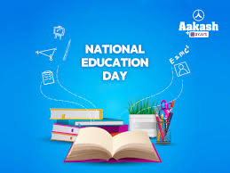

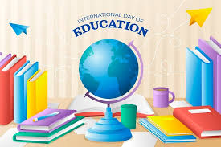

# National Education day



# Why education in important for us

It is a known fact that education has the power to change your entire life. Learning changes your thinking capabilities and perception. You tend to break the preconceived notions due to teaching and learning. This difference in learning helps you interact with others without prejudice and expand your horizons. The function of education is to think better and critically and help develop a perspective and opinions towards life. It can help you gain respect from others and sharpen your mind.

Education helps to change society for the better: Society consists of various kinds of people with different mindsets. A person with a plethora of ideas can discuss and dabble under various topics such as society, politics and the environment. Knowledge gained through education is powerful in helping you make the right decision and walk the right path.

**Education helps you solve issues:** Problems always come with solutions, but solving them can always be confusing and tedious, which is where education helps. An educated person can answer questions like why what, and how to every problem. The attitude of problem-solving will place him above the rest.